**TOPICS: Allowed Time:** 90 Minutes

**Instructions: Total Marks: 35**

1. Gossips are not allowed.
2. Teacher assistants are for your help, so be nice with them. Respect them as they are teaching you. Raise your hands if you have some problem and need help from TA. Avoid calling them by raising your voice and disturbing the environment of Lab.
3. TA may deduct your marks for any kind of ill-discipline or misconduct from your side.
4. Evaluation will be considered final and you cannot debate for the marks. So, focus on performing the tasks when the time is given to you.
5. Paste the query as well as result table screenshot as a result of each task

**Task 01: _________________________ ___________ (08 Marks)**

1. Display the number of transactions that occurred in each month and year. This can help identify seasonal patterns in transactions.

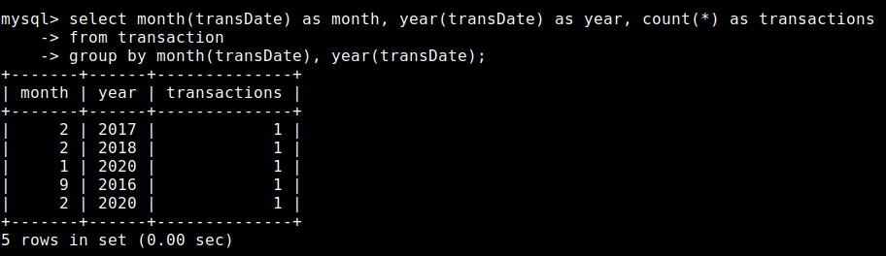

1. Count the number of high-value transactions (over 5000) per month

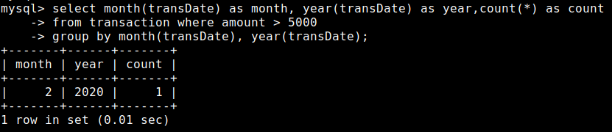

1. List each department along with the average salary of employees within that department, excluding departments with an average salary below 2000.

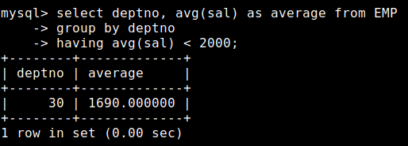

1. Display each job title and the maximum salary for that job across all departments, but only include job titles where the maximum salary is greater than 2500.

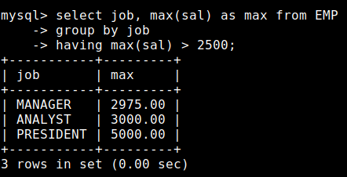

1. Classify employees into salary ranges: "Low" for salaries below 1500, "Medium" for salaries between 1500 and 3000, and "High" for salaries above 3000. Display the employee name, salary, and classification.

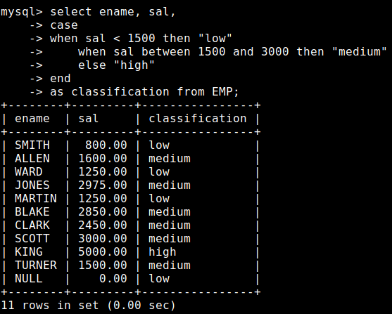

1. Count the number of employees in each department who have "High" (above 2000) and "Low" (2000 or below) salaries.

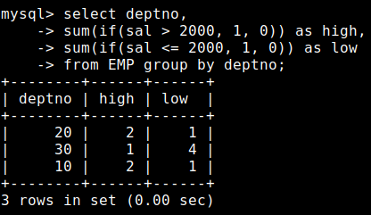

1. Count the number of employees with and without commission in each department, giving insight into the prevalence of commission-based roles by department.­

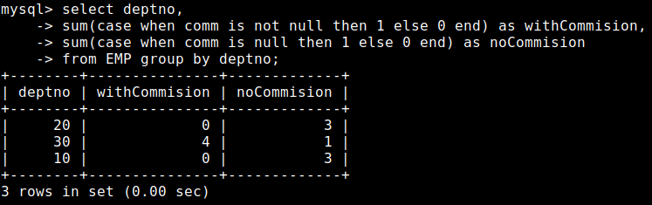

1. List each department that has more than two distinct job roles.

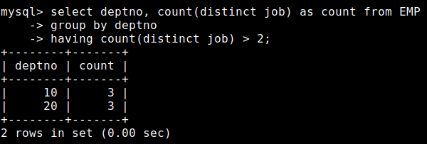

**Task 02: _________________________ ___________ (14 Marks)**

1. Calculate the minimum and maximum balance across all cards and display only if the maximum balance is more than twice the minimum balance.

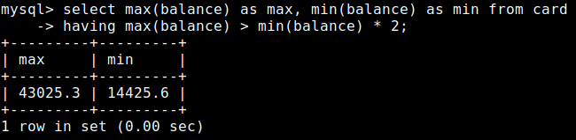

1. Categorize employee salaries into levels Low, Medium, High on salary ranges and to calculate the average salary for each category. Salary range (Low for employees where salary is less than 1000),(Medium For employees where salary range between 1000 and 3000 inclusive) and (High for employees where salary is more than 3000)

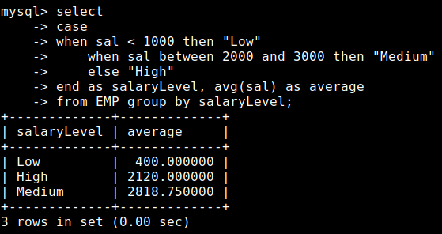

1. Show TransId, TransDate, and each user's average transaction amount across all their cards, labeling each as "High", "Medium", or "Low" based on thresholds of 3000 and 1000.

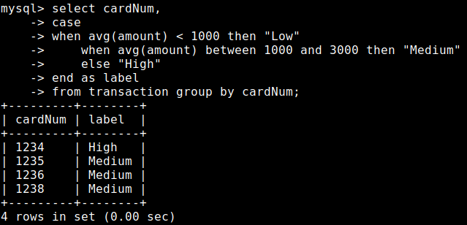

1. Display the maximum balance for each card type, but only show types where the difference between the maximum and minimum balance is greater than 15,000.

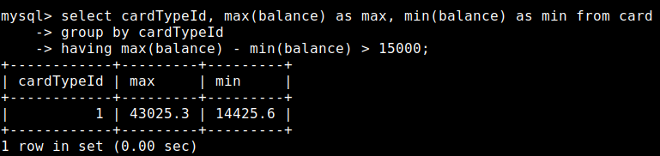

1. Write a query to display the name, sal, and commission of the employee along with net-sal column which contains net salary of emplyees that is basically sum of their salary and their commission.
2. Increament salary by 500 if employee earns more net salary than sal.

b. Increament salary by 1000 if employee earns equal salary and net salary.

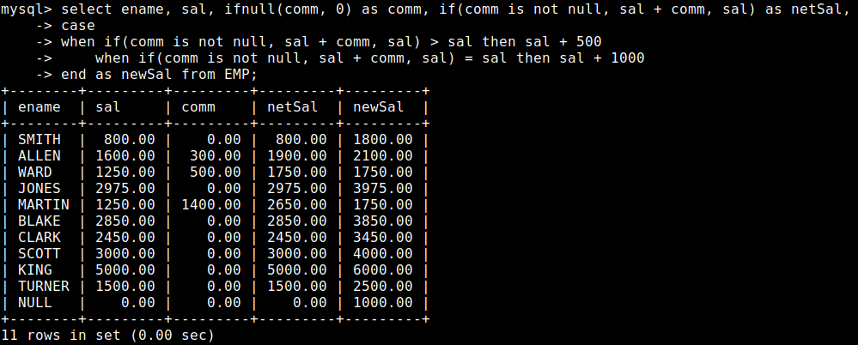

6. The employees are hired in the last century and the current century. Display empno, ename, hiredate, *hired century* from emp table. The *hired century* is either the current century or the last century.

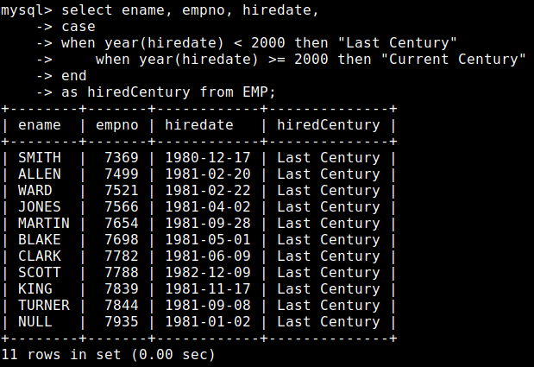

7. Display empno, ename, job, sal, tax, and net sal from the emp table. Tax is calculated based on the following :

* Salary less than 1000: No tax.
* Salary from 1000 to 1499: 5% tax.
* Salary from 1500 to 1999: 8% tax.
* Salary from 2000 to 2499: 10% tax.
* Salary 2500 and above: 12% tax.

The net sal is calculated by subtracting the calculated tax from the sal.

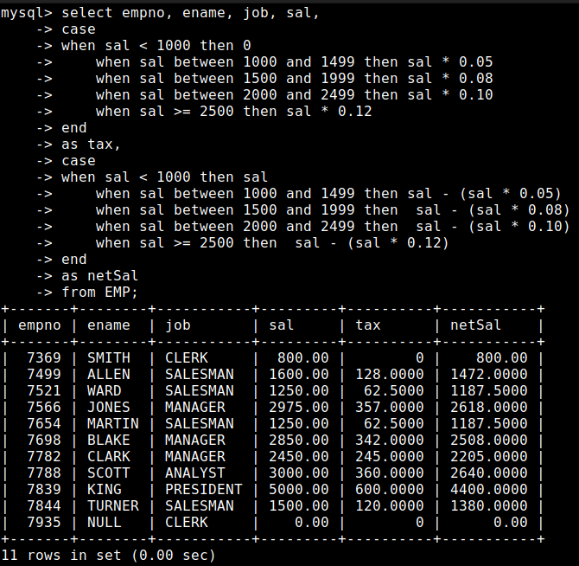

**Task 03: _________________________ ___________ (05 Marks)**

Write a query to display the following:

**Employee Details**: Show the employee’s name, job title, original salary, and commission.

* **Base New Salary**: Calculate a new salary with the following conditions:
* Increase by 10% for managers with a salary above 2000.
* Increase by 7% for salesmen with a salary between 1000 and 2000.
* Increase by 12% for analysts.
* Apply a 5% increase for all other cases.
* **Final Salary**: Adjust the base new salary further with these conditions:
* For managers with salary above 2000 and commission over 500, increase by 15%.
* For salesmen with salary between 1000 and 2000 without commission, increase by 9%.
* For clerks with salary below 1000, increase by 2%.
* For other cases, apply an 8% increase if commission is 300 or more; otherwise, 5%.
* **Increment Percentage**: Show the percentage increase applied based on the final salary conditions.
* **Salary Level Classification**: Classify each employee’s final salary into levels as follows:
* "Executive" if final salary is 3000 or more.
* "High Salary" for 2000–2999.
* "Medium Salary" for 1500–1999.
* "Low Salary" for 800–1499.
* "Very Low Salary" for below 800.

Only display employees with a final_salary greater than 1500.

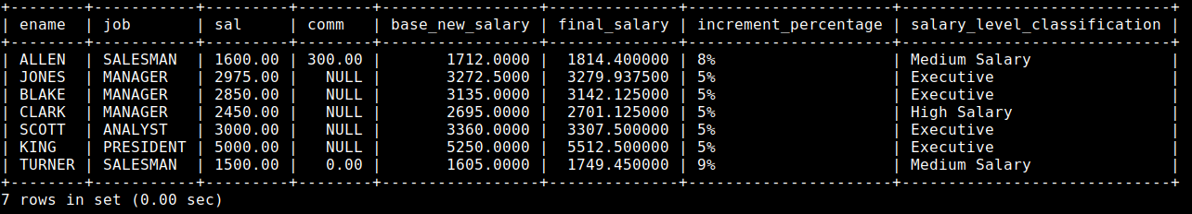

**Task 04: _________________________ ___________ (05 Marks)**

Write a SQL query to display the following details and calculations for each employee:

* **Employee Information**:
* Display the employee’s name in uppercase.
* If an employee's job is "MANAGER" and their original salary is above 3000 or commission exceeds 500, set their job title to "SALESMAN." Otherwise, show the original job title in lowercase.
* Display the original salary.
* **Adjusted Salary Based on Complex Conditions**:
* If the employee’s job (after possible reassignment to "SALESMAN") is "MANAGER" and their original salary is between 1500 and 2500, increase the salary by 8%. If their commission is NULL, add an additional 2%.
* For all other employees with a salary below 1500, increase by 10%. If they are a "CLERK," add an extra 5%.
* Calculate the number of characters in each employee’s name.
* Display the employee’s name in reverse order.
* **Commission Analysis**:
* Show commission as 0 if it is NULL.
* Display “High Commission” if the commission is above 1000, otherwise “Standard Commission.”
* **Total Earnings**:
* Calculate total earnings by adding the adjusted salary and commission.
* Display only employees whose total earnings are greater than 2000 (using HAVING).
* **Overall Salary Statistics**:
* Calculate the **average salary** and **maximum salary** across all employees.
* Approximate the midpoint between the minimum and maximum salaries.

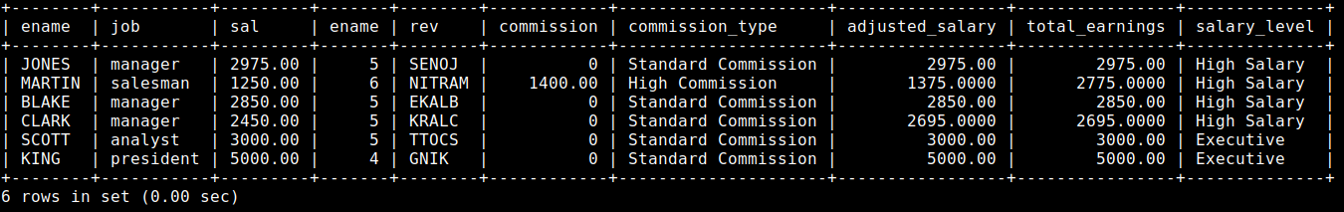

**Viva voice: _______________________ ___________ (03 Marks)**